QNA
- Business risk/ assumptions
  - Market readiness- people wants living biofilter more than physical filter
  - Algae air regenerator is cheaper than normal air purifier
  - Consumer willing to pay a monthly refill subscription/ pay once for a year/ half year/ quarter
  - People can accept to maintain the biofilter
    - discarding 80% volume and top up with nutrient media
  - Existing player cannot copy easily
- Technical risk/ assumptions
  - Algae air regenerator is functionally as competitive as normal air purifier → How to test it?
  - IOT Smart characteristics can be added at low cost
  - 30 days maintenance cycle can be maintained
  - Certification is achievable

No. | Risk | MVP solution | Remarks
1 | Algae air regenerator is functionally as competitive as normal air purifier | List down how to test it, areas of testing | Do literature review (it works)  HEPA filter can be included to make it more competitive
2 | Market readiness- people wants living biofilter more than physical filter  They can accept monthly subscription, and self maintenance | Social media content  Linked in  Direct to website to sign up waiting list | Refer to Algen Air, Algreen
3 | IOT Smart characteristics can be added at low cost  Algae air regenerator is cheaper than normal air purifier | Buy few sensors test reliability and add up their cost | Research the plan of current air purifier
4 | 30 days maintenance cycle can be maintained  The refill media works  Consistent performance | 30 days observation  Cycle observation | Glass  Light  Air pump  Anti-leakage design

MVP sequencing to de-risk with limited resources
Order matters — test the assumption most likely to kill the company first, and the cheapest thing to test first when risks are tied.
- Desk validation (cheapest, do first): Customer discovery interviews with 15-20 real potential buyers (city sustainability officers, developers, highway authorities, mall operators). Goal: find who actually has budget and pain, not who says "cool idea." This alone will likely narrow your beachhead for you. Should got buyers.
- Reliability MVP (the real technical test): One instrumented module, in a real outdoor location, unattended, run for 6-12 months minimum. Track uptime %, culture stability, contamination events, labor hours needed, auto-harvest failure rate. This is the make-or-break dataset — don't scale form factors until this is solid. Test 2
- Independent performance verification: Partner with a university lab or accredited third party to verify your CO2/PM removal claims on that same module. This becomes reusable proof for every future sale. Test 1
- Commercial pilot with a co-funding partner: One paying (or grant-co-funded) customer in your chosen beachhead segment. Validate willingness to pay, procurement timeline, and decision-making friction — not just technical performance. After CLLA/ Cradle
- Real unit economics at small scale: Actual cost to manufacture, install, and maintain one unit vs. target price. Identify the gap and what has to close it (service fee, credit, biomass revenue, subsidy) before committing to scale-up. After Cradle
- Only then: replicate to a second site/climate to test generalizability, and begin exploring a second form factor. After CLLA
Resist the urge to build multiple form factors in parallel right now — it feels like progress but it multiplies your unknowns instead of resolving them.

Further innovation still needed
- Resilient strains or mixed cultures that tolerate real-world temperature swings and contamination better than lab monocultures — this may matter more than any control system.
- Cheap, distributed-scale sensing for CO2/PM/biomass suited to street-furniture-scale units, not industrial photobioreactors.
- Genuinely simple maintenance — designed so a city facilities crew (not a biologist) can service it, not just marketed as simple.
- Financing innovation — results-based contracts (pay per verified ton of CO2 or measured AQI improvement) that shift risk away from the buyer during the unproven phase.
- Secondary revenue engineering — bundling with things that already have budget lines, like bus stop advertising space, local biomass offtake agreements, or aggregated carbon credit platforms for many small distributed sites.
- Aesthetic/material R&D to solve the visual and odor stigma directly, since public infrastructure has to pass a social-acceptance bar, not just a technical one.
Case study
AlgenAir — Aerium
Origin
Pittsburgh, USA. Founded by two PhD marine biotechnology researchers (Dan Fucich + Kelsey Abernathy). Launched November 2019.
Scale reached
~500 units sold. 130+ active subscribers by May 2022. Distributed via Brookstone + Touch of Modern. 8 countries.
Current status
Device listed as sold out / paused. Website states "shipping expected to resume Q3 2025 due to product upgrades and supply constraints." Refills still shipping. No confirmed scale-up.
Price
$249 USD device. Refill subscription $15–30/month.

AlGreen — VAYU
Origin
Hong Kong. Founded by Dhruv Manoj Jain. Based at Hong Kong Science Park (HKUST spinout). Kickstarter launch ~2023–2024.
Scale reached
Kickstarter backers. Featured in South China Morning Post. Retail price HKD $1,499 (~USD $185). Still operating, actively marketing as of 2025.
Current status
Active but small. Still in early commercialisation phase. No public subscriber count or revenue figures. Primarily DTC via website.
Price
From $185 USD. Nutrient refill from $21 USD. Algae refill $7.99 USD.

The honest read on both companies
Neither company has failed in the sense of closing down — but neither has achieved meaningful scale. AlgenAir reached ~500 units in 3 years, which is hobbyist territory, not a business. VAYU is still in early market. Both have enthusiastic niche customers but are stuck in the "interesting product, not a market" zone. The question is not why they failed — it's why they plateaued. The answers are the same for both.
The evidence from real customer reviews is damning in a very specific way. The customers who love these products love them as living objects, as science experiments, as conversation pieces. Customers noted things like loving to see the colour of the algae change and using the spent algae as fertiliser for houseplants. But customers who bought for functional air quality reasons were consistently disappointed — one family reported their air monitor readings had not changed, and said they had "resigned themselves to dealing with the unpredictability of living organisms."

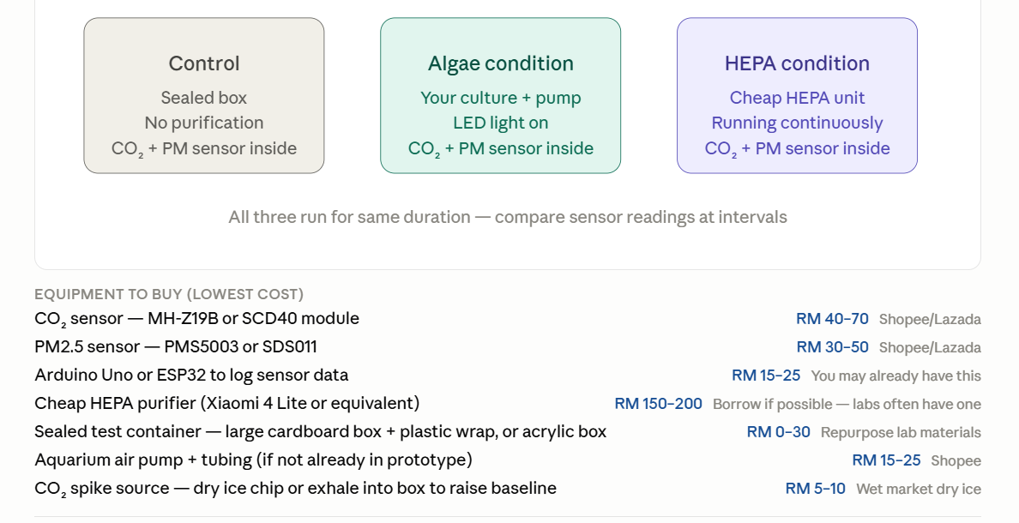

B2B/ Big projects PMF

Milestones
MVP
- Microalgae and Culture [1x, 0.75x, 0.5x, 0.25x]
Microalgae | Culture | Color | Remarks
Spirulina | Korsaric | Dark Green | Higher biofilm risk
Chlorella | BBM | Light Green | Higher contamination risk
- Product design
  - 1.5L
  - 15L
  - 50L
- Sensor and App
Sensor | Calculation | Data showcase | Remarks
RGB | - RGB → HSV → OD680nm (cells/mL)  - OD = -6.9148 + 57.5223H - 83.8247H²  - OD = -29.9848 + (-0.0306)R + (0.1512)G + (-0.000670)B  RGB → Real color (cam RGB vision)  - OD620nm → Biomass (g/L)  - Biomass= 0.325 x OD680 + 0.065  - Biomass → Oxygen & Biomass (g or L)  - CO2= 1.7X biomass (g)  - O2= 1.35X biomass (g) | - Real time Dashboard  - Cells  - CO2 absorbed  - O2 released  - Graph across time (minutes, hours, day, month)  - Cells  - CO2 absorbed  - O2 released  - Cumulative Dashboard (week, month, year, to date)  - Cells  - CO2 absorbed  - O2 released  - RGB reveals real color in AURA | Objective: Check reliability of data  - Conduct another test directly in tube and in AURA, cross check  - Compare OD from spectrophotometer vs calculation model
SCD41 CO2 | - CO2 (ppm)  - Humidity (%)  - Temperature (C) | - Real time Dashboard  - Graph across time (minutes, hours, day, month)  - Average Dashboard (Day, Week, Month, Year) | Give notification when the CO2 is mediocre  Color for scale for CO2  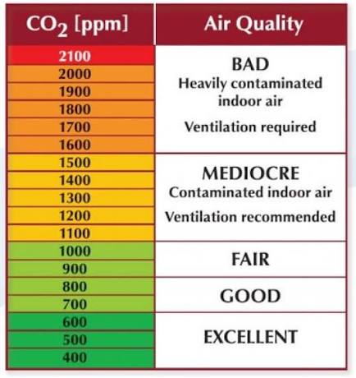
MQ135 AQI | - AQI (in voltage) overall below  - Benzene  - Alcohol  - Smoke  - Ammonia  - Sulfide  - Carbon Dioxide  - V into AQI range (color)  - Good (0-50)  - Moderate (51-100)  - Unhealthy for sensitive group (101-150)  - Unhealthy (151-200)  - Very unhealthy (201-300)  - Hazardous (301-500) | - Real time Dashboard  - Graph across time (minutes, hours, day, month)  - Average Dashboard (Day, Week, Month, Year) | Give notification when the level is unhealthy for sensitive group  Color for scale  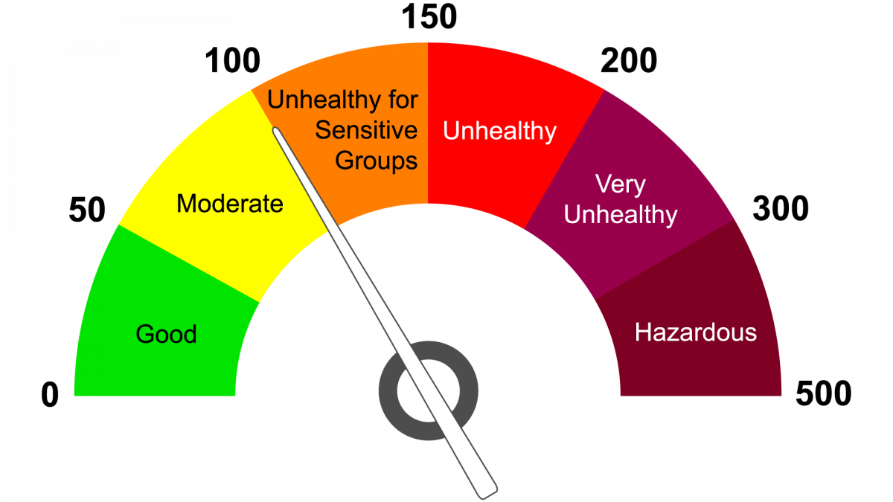
Parts | Control | App showcase | Remarks
Wifi connection | - Allow all data to be connected to the phone app | - Hardware connected to wifi (which wifi) | Algae Decarbon wants to have all data sets
Lighting | - Color  - White  - Mix color  - Strength  - 100%  - 75%  - 50%  - 25% | - Show color (Drop down)  - Show percentage (%) | Preset white (W1-25%, W2-50%, W3-75%, W4-100%)
Bubbling | - Speed (power input)  - Slow  - Moderate  - Vigorous | - Show percentage (%) | Preset (W1-25%, W2-50%, W3-75%, W4-100%)
- AI and machine learning on the data for prediction
- Harvesting system

IMPORTANT FROM MOST TO LEAST (Priority/ Urgent to the least)
- Ameen (look for all the finance data and numbers for each stage)

Phase. | Design | Technical | Automation | Others (Risk)
1 | Body, Material, Shape, Dimension |  |  | - Odour  - Biofilm formation  - Electronics failure  - Leaking  - 1 L
1 | Lighting and Bubbling
2 |  | Turbidity/ Color sensor + CO2 sensor + App |  | - Scale of 10L- 100L
2 |  | Full air quality sensor (VOCs and PM) + HEPA filter
2 |  | pH, Temperature, Turbidity
2 |  | OLED Screen
3 |  |  | Harvesting unit | - Constant performance
3 |  |  | Temporary storage unit | - Big scale >100L
3 |  |  | Nutrient supplementation tank

Business Experiment
Resources
- Mock up (Ideal Version + AI)
  - For Solution Page → Can make one in room then expand to a map, so like imagine a lot of item everywhere it means → 1.3L, 10L small,100L → Show impact through small become big.
- MVP

- Video

Resources + Channel
B2B (Ameen): Commercial building, property developers, hospitality (yoga/ med lab)
- User interview calls
- Letter of Intent
- Conference/ Exhibition [Sustainability, Climate, Air Quality]
- Find one customer do the best to help them solve it for free

B2C (Arvel): Health/ Ecoconscious urban individuals
- Content creation
- Website Landing page
- Sign up form
- Expo [Air Quality, Smart furniture/ living]
- Find one customer do the best to help them solve it for free

Website references
MASTERSHEET- ALGAE DECARBONISATION

Focus/ Narratives/ Pillar
- Climate/ Environment
- People Wellness
- Development journey
- Sign up list to try out + New products pushing out

Executive Summary

Executive Summary
Algae Decarbon is a sustainability-driven company developing microalgae-powered carbon capture and air regenerative systems for modern urban environments. Our mission is to bring cleaner air and climate-positive living to people’s lives by transforming indoor spaces into healthier, living, and regenerative environments. Through biological carbon capture, and air filtration, we transform working and living spaces to be more sustainable, climate-resilient, and engaging.

The Problem
Climate change and rapid urbanization resulting in unhealthy and unsustainable living environments for people. Modern cities, offices, and indoor spaces are increasingly exposed to high CO₂ concentration, airborne pollutants, poor ventilation, and limited connection with nature, affecting both environmental sustainability and human well-being.
Gaps: Existing air purification and related green facilities are not biophilic, visually uninspiring/ modern, and disconnected from ESG engagement and sustainability awareness.

Our Solution
Algae Decarbon develops biological carbon capture, utilization, and air regenerative systems powered by microalgae. Our systems naturally absorb CO₂ while helping improve air quality through oxygen generation and biological filtration of air pollutants. Beyond carbon reduction, our solutions integrate environmental monitoring, ESG data dashboards, and biophilic visual experiences to create healthier, smarter, and more climate-positive environments. By combining sustainability, air regeneration, and living design, our systems transform environmental action into a visible and interactive experience.

Business Model & Value Chain
Our business model combines initial system delivery with subsequent monthly subscription-based. This lowers customer entry barriers while ensuring recurring revenue and long-term engagement. Customers receive starter culture (optional) and nutrient media on a monthly basis.
Systems can have options in size, lighting appearance, and functionality according to space requirements, creating unique and engaging sustainability showcases.

Market Opportunity
- People consciousness on indoor air quality
- People’s behavior to spend on ambience/ indoor calmness gadget
- Disrupt the air purifier market and create a new category air regenerator

Impact & Vision
Our vision is to create healthier, more climate-resilient cities by integrating living regenerative systems into everyday environments. We aim to make sustainability visible, interactive, and accessible while contributing toward cleaner air, reduced carbon impact, and improved urban well-being. By transforming spaces into living environmental ecosystems, we envision a future where climate action, air quality, and human wellness coexist naturally in the places people live, work, and gather.

Problem and solution

Problem and solution

Clients

90% of world population live in cities

People spend a lot of time in indoor (90% time)

Air Quality in SEA is declining (moderate to poor) due to severe seasonal haze, land use changes, urban and industrial growth
Problem | Solution
Air quality  - Particulate matter  - VOC: Benzene, Ammonia, Sulphide  - CO  - Enclosed space with weak ventilation  - People wellness | Dual Filter HEPA and /or Microalgae (solely)
Rising CO2 level and reduced O2  - Reducing productivity  - Increase temperature  - Less trees and forests | Microalgae to photosynthesize
People disconnecting from green/ nature  - Plants are lesser in cities | Aesthetic air regenerator
Biophiliic ambience  - Modern with elegance  - Calmness with the Green | Aesthetic air regenerator

- Technology/ Technical

Area | Problem | Solution
Sensor | Do we still need sensing?  - External environment- Air quality, temperature, humidity  - Internal environment- Color/ turbidity + pH | If the sensor costs less then can proceed.
O&M | Fouling and contamination  - Biofilm formation  - Wall fouling  - Sensor fouling  - Contamination  Heavy maintenance  - Cleaning  - Sensor calibration  - Nutrient/ culture replacement  Risk of failure  - Safety  - Reliability across time | Have to make the system extremely easy to take care of and look good across time.
Harvesting | Harvesting contributes a lot to the operational cost. Without harvesting  - Productivity drops | Subscription delivery of concentrated media (monthly/ quarterly/ yearly).  Easy harvesting- discard until 20% then add on concentrated media and water.  Confirm suggested harvesting cycle

- Business

Area | Problem | Solution
Value proposition | People can trust biofilter works better than normal purifier | Facts, Certs  Ambience
Competitor | Easy to replicate | - Design  - System  - Patent

Competitor analysis

# | Pattern (Problem in Market) | Gap (What's Missing) | Solution (Algae Decarbon's Approach)
1 | Uncontrolled die-off — living cultures collapse unpredictably; competitors just apologize after the fact with no real fix | No engineered reliability system; die-off treated as an accepted "unpredictability of living organisms" | Actively manage culture stability via pH monitoring/control as the primary lever, with a HEPA filter layer as a future safeguard against contamination-driven crashes. Frame as an evolving reliability roadmap, not a solved problem — set expectations honestly while you iterate
2 | Novelty/gadget positioning — sold on gift/gadget sites alongside "weird stuff," capping perceived value and repeat purchase | No brand occupies the wellness/lifestyle category seriously; buyers treat it as a curiosity, not a considered purchase | Position explicitly as a wellness object, same category as air quality, sleep, focus, and calm-space products, not just "cool gadget." Carry this through sales & marketing execution consistently
3 | Efficacy skepticism — bold claims ("25 houseplants," "80% CO2 reduction") without visible proof; users report no measurable change on their own monitors | No independent verification; claims outrun trust, especially with analytical/skeptical buyers | Run in-house efficacy experiments early (real before/after CO2 ppm data, published transparently) and pursue third-party certification progressively as you scale — credibility built in stages, not claimed upfront
4 | Invisible mechanism — users can't see or understand what the algae is actually doing, so "trust the science" is a hard sell | No feedback loop connecting the living system to a quantified, personal outcome | Build an app that tracks algae cell count and growth over time, and back-calculates estimated CO₂ absorbed / O₂ released into a personal dashboard — makes the invisible process visible, trackable, and shareable (also your ESG differentiation vs. both competitors)
5 | Subscription trust breakdown — surprise billing, unclear refill cadence, customers requesting refunds repeatedly | No flexible, transparent, user-controlled subscription structure | Offer 1 / 3 / 6 / 12-month refill tiers, with built-in in-app purchase/card billing — user chooses cadence and commitment level upfront, reducing surprise charges and giving predictable renewal control
6 | DTC-only, geography-locked — fragile living cultures are costly/slow to ship internationally, no real SEA presence from either competitor | Neither AlgenAir nor AlGreen serves SEA pricing, logistics, or climate context | Launch DTC in SEA first — local pricing (MYR), faster fulfillment, climate-appropriate design/support. Longer-term, freeze-dried algae removes the live-shipping constraint entirely, opening a path to global logistics without the fragility problem

A few things worth stress-testing as you move forward:

Row 1 (die-off) is still your highest-risk item — pH control helps, but it's worth being honest with yourself about how much of this is truly solvable at a 1–5L consumer scale vs. an inherent limitation of the category. This is exactly what your 5 pilot users should stress-test hardest.

Row 4 (app dashboard) is genuinely your strongest structural differentiator — neither competitor has this, and it converts an invisible biological process into a tangible, personal, shareable metric. Worth featuring prominently in both your landing page and investor narrative. Reminder and purchasing platform as well. New trend as in grow your algae (like its pet- Pou) Form the community.
  - 

Row 3 (certification) — worth deciding now what "early experiment" evidence looks like (even simple CO2 meter before/after logs from your 5 pilots) so you have real numbers to show your accelerator, not just anecdote.

The Reality of the Problem
Many climate startups fail because they solve a problem that people don't actually feel.
You are attacking something people experience every day but rarely notice:

1. Humans Are Spending More Time Indoors Than Ever
Research consistently shows modern people spend around 90% of their time indoors.
Think about it.
People:
- Work indoors
- Study indoors
- Shop indoors
- Sleep indoors
- Exercise indoors
Yet most sustainability solutions focus on:
- Forests
- Solar farms
- Carbon credits
- Renewable energy projects
All important.
But they are often invisible to ordinary people.
A person sitting in an office in Kuala Lumpur, Johor Bahru, Singapore, or Shanghai cannot see those sustainability efforts.
They cannot feel them.

2. Indoor Air Quality Is an Invisible Health Problem
Most people worry about outdoor pollution.
But indoor air can sometimes be worse.
Problems include:
- Elevated CO₂
- VOCs from furniture and paint
- Particulate matter
- Poor ventilation
- Sick building syndrome
High indoor CO₂ levels have been associated with:
- Reduced cognitive performance
- Fatigue
- Drowsiness
- Reduced decision-making ability
The irony:
Modern buildings are becoming more energy efficient.
But they are also becoming more sealed.
So we save energy while trapping people inside increasingly artificial environments.

3. Urbanization Is Disconnecting Humans From Nature
By 2050, roughly two-thirds of the world's population is expected to live in urban areas.
Cities are growing.
Concrete is growing.
Glass towers are growing.
Nature is shrinking.
People increasingly experience:
- Stress
- Burnout
- Mental fatigue
- Lack of biophilic connection
Humans evolved surrounded by living ecosystems.
Now many spend entire days surrounded by:
- Screens
- Concrete
- HVAC systems
This is not how our biology evolved.

The ESG Problem Nobody Talks About
Many organizations want sustainability.
But sustainability is often invisible.
Examples:
Company spends RM100,000 on:
- Carbon credits
- Renewable energy certificates
- Tree planting
Employees never see it.
Visitors never see it.
Customers never see it.
The impact exists.
But engagement doesn't.
This creates a major gap:

ESG is often reported.
But not experienced.
That is the opportunity.

What Algae Decarbon Is Actually Building
Many people will think:
"Oh, it's an algae air purifier."
No.
That's too small.
You are building:

Living Sustainability Infrastructure
The product is not algae.
The product is not carbon capture.
The product is not oxygen.
The product is:
A visible, measurable, interactive sustainability ecosystem.
Imagine entering a building.
Instead of seeing another decorative plant:
You see:
- Living microalgae
- Real-time CO₂ data
- Air quality metrics
- Oxygen production estimates
- ESG impact dashboard
- Sustainability stories
Suddenly climate action becomes tangible.

Why Microalgae Matters
Microalgae are among the most efficient photosynthetic organisms on Earth.
Compared to terrestrial plants:
- Faster growth rates
- Higher photosynthetic efficiency
- Can be cultivated in compact spaces
- Can continuously regenerate biomass
That doesn't mean one algae unit replaces a forest.
And you should never market it that way.
The real advantage is:

Trees need land.

Algae can exist where people already are.
Inside:
- Offices
- Universities
- Airports
- Shopping malls
- Hotels
- Hospitals
The value is proximity.

The Hidden Opportunity
Many founders think they are selling a product.
The strongest companies sell outcomes.
You are not selling:
- A tank
- A photobioreactor
- Sensors
- An app
You are selling:

Healthier Spaces
For:
- Offices
- Schools
- Universities
- Hospitals

Sustainability Engagement
For:
- ESG departments
- CSR teams
- Property developers

Biophilic Experience
For:
- Architects
- Interior designers
- Green buildings

Environmental Intelligence
For:
- Facility managers
- Smart buildings
- Future smart cities

Why This Could Become Bigger Than Carbon Capture
Most founders are thinking:
"How much CO₂ can we remove?"
That is the wrong first question.
The better question:
"How many environments can we improve?"
Because customers buy solutions to problems they experience.
They experience:
- Poor air quality
- Uninspiring spaces
- ESG reporting pressure
- Sustainability communication challenges
- Occupant wellness concerns
Those are budgets that already exist.

The Long-Term Vision
Today:
- Algae unit
Tomorrow:
- Connected algae network
Then:
- Building-level environmental ecosystem
Then:
- City-scale environmental infrastructure
Imagine:
Every office tower.
Every university.
Every airport.
Every transit station.
Every hospital.
Containing living regenerative systems connected through a common platform.
Not just monitoring air quality.
Actively improving it.
Generating environmental data.
Educating people.
Making sustainability visible.

The Mission Worth Building
A lot of climate technology works far away from people.
Wind farms.
Solar farms.
Carbon capture plants.
Industrial decarbonization systems.
Those matter enormously.
But they are distant.
Algae Decarbon has the chance to bring climate action into everyday life.
Your mission is not:
"We build algae systems."
Your mission is:
We transform spaces where people live, work, learn, and gather into living regenerative environments that make sustainability visible, measurable, and beneficial to human well-being.
And your vision is not:
"Capture more carbon."
It is:
Create cities where environmental regeneration is integrated into everyday life, allowing people to experience cleaner air, healthier spaces, and visible climate action wherever they go.
That vision sits at the intersection of:
- Climate technology
- Human health
- Smart buildings
- Urban sustainability
- ESG engagement
- Biophilic design

Air Quality SEA
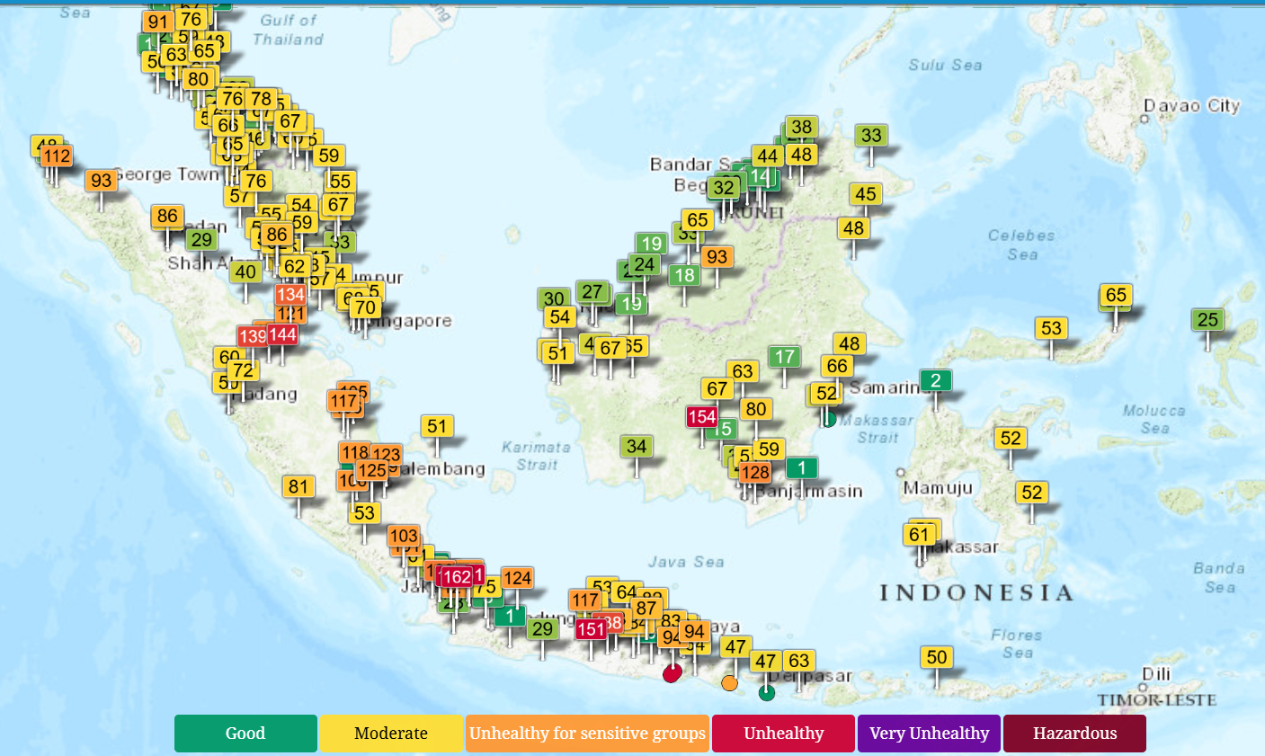
https://aqicn.org/map/malaysia/

Outdoor Air Quality
Outdoor (ambient) air pollution is driven primarily by fossil fuel combustion, transport, and industrial activity. [1]
- Primary Pollutants: Includes particulate matter (PM2.5) and PM₁₀), nitrogen dioxide (NO₂), sulfur dioxide (SO₂), and carbon monoxide (CO). [1]
- Ground-Level Ozone (O₃): This is not emitted directly but formed when pollutants react with sunlight (photochemical smog). [1]
- Health Impact: The World Health Organization (WHO) Ambient Air Quality Information (24 October 2024) notes that ambient pollution contributes heavily to heart disease, stroke, and lung cancer, causing millions of premature deaths globally. [1, 2, 3, 4, 5]
  - In 2019, 99% of the world’s population was living in places where the WHO air quality guidelines levels were not met.
  - The combined effects of ambient air pollution and household air pollution are associated with 6.7 million premature deaths annually.
  - Ambient (outdoor) air pollution is estimated to have caused 4.2 million premature deaths worldwide in 2019. due to exposure to fine particulate matter, which causes cardiovascular and respiratory disease, and cancers.
  - Some 89% of those premature deaths occurred in low- and middle-income countries, and the greatest number in the WHO South-East Asia and Western Pacific Regions.

Pollutants
  - Particulate matter (PM)
PM is a common proxy indicator for air pollution. There is strong evidence for the negative health impacts associated with exposure to this pollutant. The major components of PM are sulfates, nitrates, ammonia, sodium chloride, black carbon, mineral dust and water.
  - Carbon monoxide (CO)
Carbon monoxide is a colourless, odourless and tasteless toxic gas produced by the incomplete combustion of carbonaceous fuels such as wood, petrol, charcoal, natural gas and kerosene.
  - Ozone (O₃)
Ozone at ground level – not to be confused with the ozone layer in the upper atmosphere – is one of the major constituents of photochemical smog and it is formed through the reaction with gases in the presence of sunlight.
  - Nitrogen dioxide (NO₂)
NO₂ is a gas that is commonly released from the combustion of fuels in the transportation and industrial sectors.
  - Sulfur dioxide (SO₂)
SO₂ is a colourless gas with a sharp odour. It is produced from the burning of fossil fuels (coal and oil) and the smelting of mineral ores that contain sulfur.

1. The Northern Zone (Mainland)
- Countries: Thailand, Vietnam, Laos, Cambodia, Myanmar.
- When it gets bad: November to May.
- Why: Massive agricultural burning and forest fires happen during their dry winter and spring months. Cities like Chiang Mai frequently see hazardous air quality during this time.
- Right now: The air is generally clear because the annual monsoon rains have arrived, washing the pollution out of the sky.

2. The Southern Zone (Maritime)
- Countries: Malaysia, Singapore, Indonesia, Brunei.
- When it gets bad: June to October.
- Why: This region is entering its dry season. Land clearing and peatland fires—mostly in Indonesia—create heavy smoke plumes. The wind carries this toxic smoke across borders, creating the famous regional "haze".
- Current Outlook: Forecasters are keeping a close eye on this zone right now, as climate models predict an El Niño weather pattern developing, which means it will be much drier and hotter than usual—raising the risk for a tougher haze season.

Indoor Air Quality
Indoor air quality (IAQ) often poses a more concentrated threat to health than outdoor air because humans spend 80 to 90% of their time indoors where pollutants can become trapped. [1, 2]
- Sources of Pollution: Indoor air is dominated by Volatile Organic Compounds (VOCs) emitted by paints, adhesives, furniture, and cleaning agents. [1]
- Biological Contaminants: Damp environments promote mould and fungus, while burning cooking fuels creates toxic micro-particles. [1, 3]
- Radon: This radioactive, cancer-causing gas can seep into buildings from soil and rock formations. [1, 2]
- Mitigation: The U.S. EPA Indoor Air Quality Page outlines that IAQ can be managed through source control, adequate ventilation, and air purifiers. [1]

1. Recorded Data: Malaysia
In Malaysia, the Department of Occupational Safety and Health (DOSH) under the Industry Code of Practice on Indoor Air Quality (ICOP-IAQ 2010) sets the maximum acceptable limit for indoor $\text{CO}_2$ at 1,000 ppm.

Empirical Study Findings
Setting | Recorded Range | Mean / Average | Key Observations
University Lecture Halls (2023 Field Study) | 392 – 1,919 ppm | ~804 ppm | Peaks over 1,500 ppm occur during full-capacity lectures due to closed-loop AC.
University Tutorial Rooms (2023 Field Study) | 450 – 1,250 ppm | ~665 ppm | Smaller occupant numbers yield lower baseline levels, but poor airflow still breaches 1,000 ppm.
Polytechnic Classrooms (Politeknik Bagan Datuk) | 530 – 723 ppm | ~610 ppm | Maintained within acceptable limits under moderate occupancy (14–24 students).
Commercial Area Classrooms (MJMHS Study) | 550 – 950 ppm | ~710 ppm | Indoor/Outdoor ratio averages 1.24x higher than ambient outdoor air.

2. Recorded Data: Southeast Asia
Across Southeast Asia, high ambient heat and humidity lead to heavy reliance on sealed, air-conditioned spaces with recirculation mode enabled, frequently causing $\text{CO}_2$ accumulation.
Location & Setting | Recorded CO2​ Range | Average / Peak | Context
Thailand (University Hospital Offices, Chiang Mai) | 434 – 1,210 ppm | 796 ± 191 ppm | ~12% of recorded office days exceeded the 1,000 ppm comfort threshold.
Singapore (High-Density Office Buildings) | 600 – 1,100 ppm | ~750 ppm | Modern Green Mark-certified buildings actively manage mechanical ventilation to stay $<800$ ppm.
Regional Tropical Schools & Daycares | 500 – 2,500+ ppm | ~1,200 ppm (Peak) | Densely occupied rooms with closed windows and split-unit air conditioners show significant $\text{CO}_2$ spikes.
Commercial Offices (US & Europe):
- US EPA BASE Study (100 office buildings): Average peak of 1,260 ppm (max ~2,200 ppm).
- European Office Buildings (56-building study): Averages ranged between 600 – 1,000 ppm.
Bedrooms Worldwide: Overnight readings in sealed bedrooms (windows closed, 2 occupants) routinely reach 1,200 – 2,500 ppm by morning.
Schools & Classrooms (Global Average): High-occupancy classrooms with poor fresh-air intake routinely average 1,200 – 1,800 ppm, with unventilated peak readings exceeding 3,500 – 5,000 ppm.
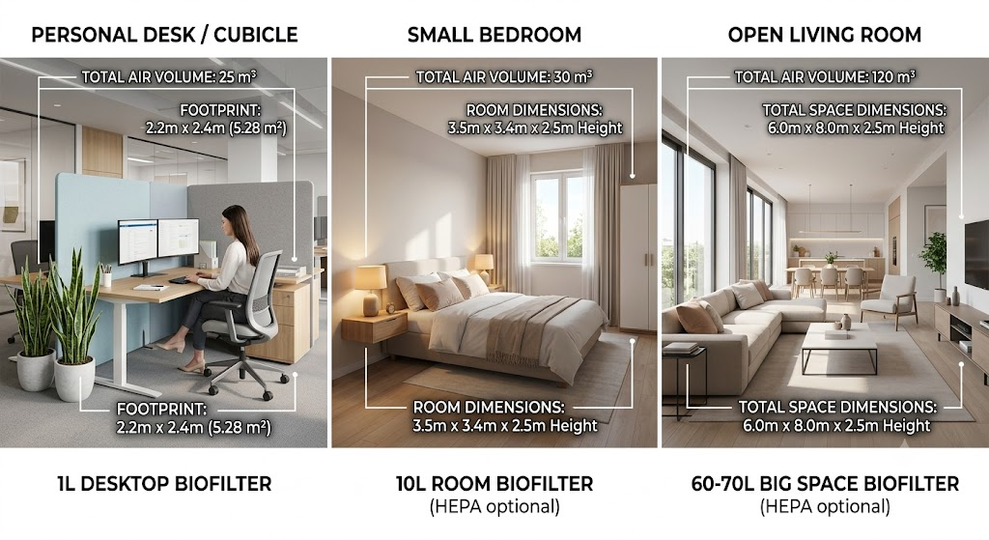
ALGAE IMPACT AS AIR REGENERATOR
Metric | 1 L Desktop Biofilter | 10 L Room Biofilter | 60–70 L Large Space Biofilter | Indoor Houseplants (10 Medium Pots) | Mechanical Air Purifier
Recommended Space | Personal desk / cubicle | Small bedroom (30 m³) | Living room (120 m³) | Bedroom / Living room | Bedroom / Living room
CO₂ Removal | 0.15–0.35 g/day (0.08–0.19 L/day) | 1.5–3.5 g/day (0.83–1.94 L/day) | 9.0–24.5 g/day (5.00–13.61 L/day) | 0.2–0.5 g/day (0.11–0.28 L/day) | 0 g/day
Daily CO₂ Reduction | −2.8 to −6.5 ppm/day (30 m³) | −28 to −65 ppm/day (30 m³) | −42 to −113 ppm/day (120 m³) | −3.7 to −9.3 ppm/day (30 m³) | 0 ppm
O₂ Production | 0.11–0.26 g/day (0.08–0.20 L/day) | 1.10–2.60 g/day (0.84–1.98 L/day) | 6.50–18.00 g/day (4.96–13.74 L/day) | 0.15–0.38 g/day (0.11–0.29 L/day) | 0 g/day
Daily O₂ Increase | +2.8 to +6.6 ppm/day | +28 to +66 ppm/day | +41 to +114 ppm/day | +3.8 to +9.7 ppm/day | 0 ppm
VOC Removal | Low (water-soluble VOCs) | Moderate (biosorption) | High (bio-scrubbing) | Very low | Very high (activated carbon)
PM2.5 / PM10 Removal | <5% (without HEPA) 99.97% (with HEPA) | <10% (without HEPA) 99.97% (with HEPA) | <10% (without HEPA) 99.97% (with HEPA) | Negligible | 99.97% (HEPA)

Microalgae
The Stoichiometry of Algal Photosynthesis
To produce 1 kilogram of dry microalgae biomass, roughly 1.6 to 1.8 kilograms of carbon dioxide ($CO_{2}$) are absorbed, and approximately 1.2 to 1.5 kilograms of oxygen ($O_{2}$) are released through photosynthesis. [1, 2]

Photosynthetic Law of Conservation: For every 1.00 kg of CO2 fixed by any plant matter, the absolute maximum chemical yield of O2 gas released is 0.727 kg (derived from the molecular mass ratio of
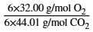

Fixed area 100m2= 10m x 10m
Areas | Trees | Dense sapling | Algae | Remarks
Number of units | 4 (25m2 x 4) | 25 (4m2 x 25) | 16000L culture (40 panels, 400L per panels)  0.2g/L/day yield
Annual Net CO2 captured (kg) | 40 | 63 | 2137 | Algae is 35X faster than dense saplings, 50X faster than medium trees
Annual Net O2 released (kg) | 30 | 45 | 1554

Branding & Marketing
Algae Decarbon

Territory/ Mind/ Emotional- Living Future Environment. [Create and define a new market]
- Market and sell the outcome/ feeling- living/ alive, biophilic, freshens air, visually aesthetic, modern/ futuristics, calm, engaging
- Make Invisible Biotechnology → Living Regenerative Environmental Experience

WHY
Bring cleaner air and climate-positive living to people's lives.
- Transforming modern indoor spaces into climate-positive environments through smart and living regenerative systems.
- Bringing fresher, healthier, and biologically enhanced air experiences into the spaces people live and work.
- Restoring biophilia by making sustainability visible, living, and interactive.

HOW
Build Smart Microalgae powered air regenerative system
- Living air regenerative systems powered by microalgae
- Smart environmental sensing and monitoring
- Managed maintenance and ecosystem care
- Modular biophilic design for modern spaces
- Real-time sustainability visualization and ESG insights

WHAT
AURA and ACCU, Environmental monitoring, ESG Data management
- AURA (Algae Urban Air Regenerative system) Living air regenerative systems powered by microalgae for modern spaces
- ACCU (Algae Carbon Capture and Utilisation system) Modular algae carbon capture and utilization platform for commercial and industrial environments.
- Digital Ecosystem- App/ Dashboard that records all environmental data, ESG analytics, and sustainability reporting platform.
- Managed Services. Subscription-based maintenance, monitoring, and ecosystem management.

We are determined to bring cleaner air and climate-positive living to people’s lives.
We do this by developing smart microalgae-powered air regenerative systems.
We build AURA and ACCU — combining air regeneration, environmental monitoring, and ESG data management for modern living and working spaces.

References
COWAY
Invisible Complexity→Simple Premium Experience
Sells: a healthier, safer, more premium lifestyle.
Market:outcome and emotion, not technology.
To improve quality of life through healthier living environments.
Helping families live cleaner, healthier, safer lives.
advertisements focus on:clean homes, happy families, modern lifestyle, peace of mind, trusted care

APPLE
Everything we do, we believe in challenging the status quo, we believe in thinking differeretly
We make products that are beautifully designed and user friendly
We just happen to make great computers → laptop —> airpods → other products

Brand Operating System
Brand Operating System
https://docs.google.com/document/d/1UXm8X90tHcVpyr_S6PZBBOhSRkrNKE_p/edit
Brand operating system. The playbook should answer one question:
How do we turn strangers into believers, believers into followers, followers into early adopters, and early adopters into evangelists?

Positioning
- Disruptor for the air purifier market (attention positioning): Conflict creates curiosity
- Creating new market air regenerator (category positioning): Educate the market

Problem
- 70% focus: Air quality > Indoor air quality > Wellness [Personal pain]
- 30% focus: Climate change > Temperature > CO2 > Environment/ Eco [Humanity pain]

Target audience
- South East Asia
- City/ Living in densely populated metro areas.
- Spend lot of time in room: rental/ Work From Home
- Adults (ages 28–45)
- Tech-forward
- Ambience forward (have nice room, cozy and comfortable)- Vlog Content creator
- High disposable income
- Might have air purifier already (people who care about their indoor air quality)
- Might have green plants (biophilic people)
- Design for me should it be that specific? Need to be more details/ should be as simple as in can be described in 1 sentence

Solution
- Smart Living Air Regenerator powered by Microalgae
- Turn CO2 into O2 as competitive as 50 indoor/ terrestrial plants
- Filter PM and VOC on the go (actual performance is only 10-20% of normal air purifier)

Team/ Us
- Graduates- Biotech (2) + Marketing (1)
- Few engineers
- Everyone deserves Naturally Clean Air + We want our future to be more climate resilient (WHY)

Development journey
- Ideation (Problem and solution)
- Development MVP: Plastic bottles → Planar with PVC and plastic bag → Cylinder acrylic + Electronics and SMART IOT → 1L → 10L (mid future) → Big structure (future)
- Business validation, challenges and pivoting, Business test
- Marketing journey

Results/ Tactical
- Ambience transformation (before vs after)
  - Feeling: People wellness + Emotion/ Ambience
  - Clients with pain + User generated content
- Product Feature and Functionality
  - Data of air quality (before vs after)
  - Experimentation

Funnel
- Funnel layers filter down people and the content to feed them (design for me)

Area | Rating | Comments
Vision | ⭐⭐⭐⭐⭐ | Very compelling. Bigger than an air purifier.
Positioning | ⭐⭐⭐⭐☆ | Good direction. Needs one dominant message.
Audience | ⭐⭐⭐☆☆ | Slightly too broad. Needs one beachhead persona.
Content Journey | ⭐⭐⭐⭐⭐ | Strong "build in public" opportunity.
Sales Funnel | ⭐⭐⭐☆☆ | Missing emotional progression.
Storytelling | ⭐⭐⭐⭐☆ | Needs more conflict and recurring themes.

Overall: 8.8/10. With refinement, I think it can become a 9.8/10 playbook.

Technical
To validate

Problem | Impact on People & Environment | Existing Gap | How Algae Decarbon Solves It
Rising indoor CO₂ concentration in offices, urban buildings, and enclosed environments | High indoor CO₂ levels (>1000 ppm) are associated with reduced cognitive performance, fatigue, headaches, drowsiness, and poor productivity. Urban buildings increasingly experience poor ventilation and trapped CO₂. | Conventional air purifiers mainly remove particles but do not actively reduce CO₂ or regenerate air. Fresh air systems are energy-intensive and costly. | AURA uses living microalgae to biologically absorb CO₂ while regenerating oxygen-rich air, creating healthier and more climate-positive indoor environments.
Worsening urban air pollution and airborne particulate matter (PM2.5, VOCs, allergens) | Exposure to PM2.5 and airborne pollutants contributes to respiratory diseases, asthma, allergies, cardiovascular risks, sick building syndrome, and reduced indoor comfort. | Most existing systems rely only on passive mechanical filtration and lack biological or regenerative air treatment. | AURA combines biological air regeneration with environmental filtration systems to help improve indoor air quality while continuously monitoring environmental conditions.
Lack of connection with nature in modern indoor spaces | Urban lifestyles and indoor environments reduce exposure to natural systems, negatively affecting mental wellness, stress levels, comfort, and overall well-being. Studies show biophilic environments can improve mood, productivity, and occupant satisfaction. | Conventional HEPA and air purification systems are visually passive, hidden, and non-interactive. | AURA introduces living biophilic environmental systems that make sustainability visible, interactive, and engaging through living microalgae installations.
ESG commitments often lack visible public engagement | Many sustainability initiatives remain invisible to employees, customers, and communities, reducing awareness and engagement. | Existing ESG reporting is often static, disconnected, and difficult for people to emotionally connect with. | AURA integrates real-time environmental monitoring, ESG dashboards, and sustainability visualization to turn environmental action into a visible experience.
Climate change and increasing carbon emissions | Rising atmospheric CO₂ contributes to global warming, urban heat stress, extreme weather, and climate instability. Governments and corporations are under increasing pressure to meet ESG and sustainability goals. | Traditional carbon capture systems are often industrial-scale, energy-intensive, expensive, and inaccessible for everyday built environments. | ACCU and AURA provide scalable biological carbon capture and air regenerative systems suitable for buildings, commercial spaces, and urban environments.
Urban sustainability initiatives lack green infrastructure | Many green initiatives focus only on reporting or passive landscaping without measurable environmental interaction. | Traditional greenery often lacks environmental monitoring, carbon data, or interactive educational value. | AURA transforms sustainability infrastructure into smart living environmental ecosystems with measurable ESG data and public engagement capabilities.

Operation

Process Flow [Consumer Self-Maintenance Model – Partial Water Replacement]
Similar to: Watering indoor plants / Aquarium water change
Maintenance cycle: Every 1 month

[Preparation] User prepares:
- Clean filtered water
- AURA Concentrated Nutrient Media (AD Media)
- Small container for discarded culture (optional measuring jug)
- The AURA app notifies the user that routine maintenance is due.
- User opens the maintenance port or tank lid.
- User pours out approximately 80% (≈1.2 L) of the existing algae culture into a container, leaving around 20% (≈300 mL) inside the tank as the starter culture.
- The discarded algae culture can be diluted 1:1 (50% algae culture : 50% water) and used as a natural liquid fertilizer for household plants.
- User refills the tank with clean filtered water until the operating level is reached.
- User adds the recommended amount of AURA Concentrated Nutrient Media (AD Media).
- User closes the tank and resumes normal operation.
- The remaining algae culture naturally repopulates the fresh media, returning the system to normal operation over the following days.
- The app resets the maintenance schedule and continues monitoring system performance.

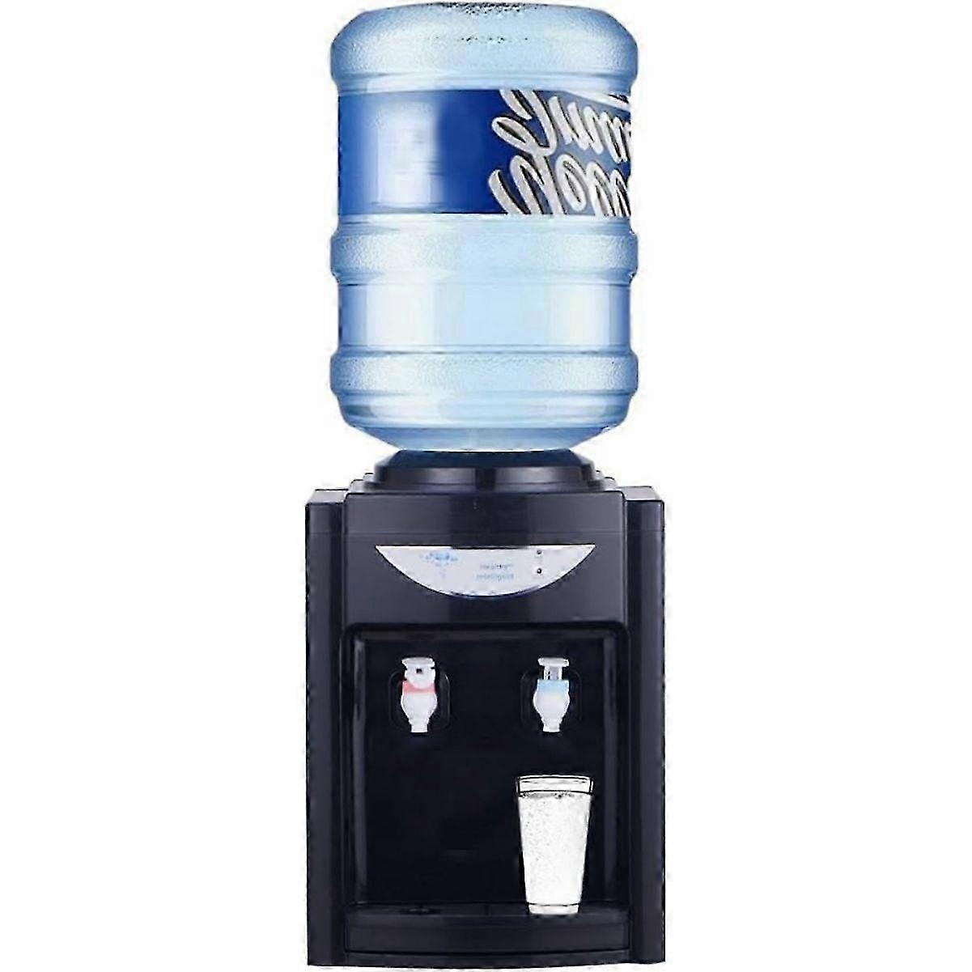
Process flow [Direct liquid exchange model – no harvesting unit, centralized biomass processing]

Similar to Water Barrel/Dispenser Business

Maintenance cycle: 1.5–2 months

[Preparation] Operator brings:
Pre-mixed replacement culture media
Portable motor pump
Rubber hoses
Empty transport tank / collection barrel
Replacement HVAC air filter (if needed)

- Operator arrives on-site with pre-mixed replacement culture media, collection barrel, hoses, motor pump, and replacement filters.
- Operator connects the drainage hose from the AURA culture outlet to the empty collection barrel until 20%.
- Existing algae culture is pumped entirely from the AURA tank into the collection barrel.
- Operator disconnects the collection hose and reconnects the inlet hose from the pre-mixed culture media tank to the AURA water inlet.
- Fresh pre-mixed algae culture media is pumped into the AURA tank.
- Refilling stops automatically once the system reaches approximately 80% operating volume, with notification from the app/system.
- Operator replaces the air filter if required.
- Operator performs a final system check, verifies circulation and airflow, and resumes normal operation.
- Operator transports the collected algae culture back to the processing facility for centralized harvesting, biomass processing, media recycling, and re-cultivation.

Advantages
Simpler on-site maintenance workflow
Lower contamination risk
No on-site harvesting required
Better quality control through centralized biomass processing
Minimal customer handling or involvement
Reduced requirement for on-site water source access
More standardized servicing SOP

Risks
Higher liquid transport volume
Heavier logistics requirements
Increased transportation cost
Potential spill/leakage risk during transport

When you bring spirulina into contact with a glass surface in the presence of water, the spirulina sticks to the glass due to electrostatic attraction and the physical adhesion of the water. Rather than canceling each other out, the charge and the water molecules cooperate to bind the materials together. [1, 2, 3, 4, 5] How to solve this issue?

Biofouling prevention
- Preventative surface modifications
  - Nano-Silica Coatings (Liquid Glass / Ceramic Coatings)
  - Food-Grade PDMS (Silicone) Spray
- Operational controls
  - High fluid velocity “Reynolds number” turbulent flow via optimized pumping forces cell to stay in suspension
  - Air sparging creating physical shear stress along the reactor wall
- Scheduled cleaning cycles
  - Mechanical magnetic wiper
  - People maintenance
- Biological/ chemical
  - Surfactants- SDS, Triton X/ Tween 20
  - Organosilicon compounds

Use AI to learn? Prevent biofouling formation by increasing strength in bubbling and harvesting (not too thick until it will clump)?

Bioluminescence (dinoflagellates: Noctiluca scintillans) and Fluorescence microalgae → aesthetics

Sensor list
Sensor list (IMPORTANT)

No | Items | Price (RM) | Status | Remarks | Data
1 | Temperature for solution | 6.22 | Not tested | 10L AURA
2 | Honde Stainless Steel Water Turbidity Sensor | 1175  USD290  RM1,181.32 | Not tested  Just arrived  Assembly and calibration needed | 10L AURA
3 | MQ135 Air Quality Sensor Module | 6.8 | Not tested | 10L AURA
4 | PM2.5 sensor | 47.68 | Not tested | 1L AURA
5 | Scd 41 CO2 sensor | 79.74 | Functioning, very sensitive | 1L AURA | CO2 ppm  Humidity %  Temperature C
6 | TCS34725 TCS 34725 RGB Color Sensor | 13 | In used with 3D printed case and U-shape bypass tube | 1L and 10L AURA | R value G value B value  HEX code
7 | Air Quality Detector | 60 | Functioning, less sensitive in CO2 | Individual showcase only | CO2 in ppm  HCHO mg/m3  TVOC mg/m3  Temp C Humidity %
- Current data all collected via ESP32 and displayed at AdaFruits

RGB sensor was used to mapped out Optical density reading of spirulina culture
- Experimental raw data: Lab Works Tab RGB OD
- Machine learning outcome: OD RGB Mapping RGB OD Analysis.docx

Optical density reading of spirulina culture was used to mapped into its dry biomass in g/L (gram of spirulina dry mass per litre of culture)
- Experimental raw data: Experimental designRGB NTU OD Drymass tab Page 3
- Results in page 4

Dry biomass of spirulina culture is used to measure its CO2 reduction and O2 release, according to Stoichiometric Conversion Ratios.
- CO2 reduction (mass) is 1.83 times of dry biomass of microalgae
  - Converting to volume in (L) is 1kg CO2= 556L CO2
- O2 release (mass) is 1.3 times of fry biomass of microalgae
  - Converting to volume in (L) is 1kg CO2= 764L O2

In overall
RGB > Optical density > Dry biomass (g/L) > CO2 reduction and O2 release (g or L)

Category | Sensor | Main Purpose | AI / Intelligence Value | Priority
Biological Intelligence | Turbidity Sensor | Biomass density & growth monitoring | Growth prediction, harvesting automation, contamination detection | Critical
Biological Intelligence | pH Sensor | Culture acidity/alkalinity | Nutrient optimization, stress detection | Critical
Biological Intelligence | RGB Sensor | Culture color visualisation | Growth/ Healthiness, Visual constant | Critical
Biological Intelligence | Dissolved Oxygen (DO) Sensor | Photosynthesis activity | Oxygen modeling, biological health analysis | Very High
Biological Intelligence | Dissolved CO₂ Sensor | Carbon availability in culture | CO₂ uptake optimization | Very High
Biological Intelligence | Culture Temperature Sensor | Growth condition stability | Productivity optimization, failure prediction | Critical
Biological Intelligence | Electrical Conductivity (EC) Sensor | Nutrient/salt concentration | Nutrient depletion prediction | High
Biological Intelligence | ORP Sensor | Oxidation/reduction balance | Contamination & instability detection | Medium-High
Biological Intelligence | Chlorophyll Fluorescence Sensor | Photosynthetic efficiency | Advanced biological optimization | Advanced
Biological Intelligence | Computer Vision Camera | Visual culture monitoring | AI anomaly & contamination detection | Advanced
Environmental Intelligence | Ambient CO₂ Sensor | Indoor carbon dioxide monitoring | Occupancy & ventilation analytics | Critical
Environmental Intelligence | PM2.5 / PM10 Sensor | Airborne particle monitoring | Pollution trend analysis | Very High
Environmental Intelligence | VOC Sensor | Chemical pollutant detection | Wellness & indoor pollution analytics | Very High
Environmental Intelligence | Ambient Temperature Sensor | Indoor climate monitoring | Environmental correlation analysis | High
Environmental Intelligence | Ambient Humidity Sensor | Indoor humidity monitoring | Comfort & mold-risk analytics | High
Environmental Intelligence | Light Intensity Sensor (Lux/PAR) | Available light measurement | Photosynthesis & energy optimization | Critical
Environmental Intelligence | Noise Sensor | Acoustic activity monitoring | Occupancy & comfort analytics | Medium
Human & Building Interaction | Occupancy Sensor (PIR/mmWave/Thermal) | Human presence detection | Occupancy-air quality correlation | Very High
Human & Building Interaction | HVAC Airflow Sensor | Ventilation performance | HVAC optimization & inefficiency detection | High
Human & Building Interaction | Energy Consumption Meter | Energy usage monitoring | ROI & carbon efficiency analysis | Very High
Human & Building Interaction | Indoor Spatial Mapping (BLE/UWB/WiFi) | Crowd & environmental mapping | Environmental heatmap intelligence | Advanced
System Reliability | Water Level Sensor | Leak/evaporation monitoring | Predictive maintenance | Critical
System Reliability | Flow Rate Sensor | Circulation efficiency | Clog & pump diagnostics | Very High
System Reliability | Pressure Sensor | Pipe/gas pressure monitoring | System diagnostics | High
System Reliability | Leak Detection Sensor | Water leakage detection | Commercial reliability protection | Critical
System Reliability | Vibration Sensor | Pump/motor health | Predictive maintenance | Medium-High

Body & Risk
Let's talk about body design.
Criteria
- Chemically inert, No changing in color or reacting with media that is high salt and pH (Korsaric media). Transparent in color
  - Glass
- Coating might be needed to prevent Blue green algae like spirulina from forming biofilm onto it
  - Hydrophobic Nano-Coatings [Food grade] silica-based nano-coatings
  - Oleophobic/Hydrophilic Coatings zwitterionic polymer layer, permanent water barrier
- Should have holes on the bottom for airstones to be situated at the bottom, air pipes directly going down to the air pump? Or the air pump goes from all the way down from top (to prevent leaking). The first option is more beautifully designed, but concern on leakage issue, any solution?
  - Industrial Bulkhead Fittings with EPDM/Viton Gaskets
  - Dual In-line Check Valves (One-Way Valves)
- Lighting currently is planned to have it in three points- top, bottom, cylinder vertical. The bottom is easy because the light is just below the glass cylinder. The top is a bit hard because I'm afraid the light bulb will get damped with the vapour, and algae will grow on it. A side vertical cylinder is kinda possible with an LED strip, provided that there is an outer casing if not then not looking good aesthetically.
  - Isolate the light. Use an IP67/IP68 rated waterproof LED puck recessed into the top lid, sealed behind a clear borosilicate glass or polycarbonate barrier window.
  - COB (Chip-on-Board) LED strip
- Where should the internal sensor be positioned? Usually on top where the probes were dipped into the culture? What about the external system sensor where is the best place for them?
  - Internal System Sensors (pH, TDS/Salinity, Turbidity, Temp) Where to put them: Suspended from the top lid, pointing downward, submerged at least 5–10 cm into the culture.
  - External System Sensors (Ambient Air Quality, CO2, Moisture)Where to put them: In the lower intake chassis (near the bottom HEPA filter) and the top exhaust port. Place a second CO2 and O2 sensor at the very top exhaust vent. By comparing the bottom CO2 levels to the top CO2 levels, your app can calculate exactly how much carbon the AURA system is scrubbing in real-time.
- What should the structure and material of base, because its about 100L volume liquid with glass, so the weight is about 150kg.

RISK

1. Moisture / Humidity Risk
With an air pump bubbling 24/7:
- Water continuously evaporates.
- Small droplets (aerosols) can be generated.
- Indoor humidity may increase.
The effect depends on:
- Culture volume
- Bubble intensity
- Water temperature
- Airflow design
- Number of units installed
For a small 20–50 L system:
- Humidity impact on a large room is probably minor.
For multiple units in:
- Offices
- Hotel lobbies
- Meeting rooms
the cumulative effect may become noticeable.

2. Salt Aerosol Risk
This is the bigger concern.
If you're using a marine or high-salinity medium similar to your Korsaric-based formulation:
Bubbles bursting at the surface can create microscopic droplets containing:
- Salt
- Nutrients
- Organic compounds
If these droplets escape:
Potential issues:
- White salt residue on nearby surfaces
- Corrosion of electronics
- Deposits on glass
- HVAC contamination
This is why industrial photobioreactors generally do not leave open bubbling surfaces exposed to occupied indoor environments.

3. Odor Risk
Healthy cultures:
- Usually have little odor.
Problems arise when:
- Contamination occurs
- Culture crashes
- Dead biomass accumulates
Then you may get:
- Musty smell
- Pond-like smell
- Sulfur-like odors
Commercial customers have very low tolerance for this.

4. Noise Risk
Most people underestimate this.
Air pumps running continuously generate:
- Vibration
- Humming
- Bubbling sounds
In:
- Offices
- Meeting rooms
- Hotel lobbies
noise complaints can become a major issue.

5. Indoor Air Quality Benefits
Now the positive side.
Microalgae can:

Consume CO₂
During photosynthesis:
- CO₂ decreases
- O₂ increases
However, be careful about claims.
For most practical indoor systems:
The air-quality improvement perceived by occupants may be less significant than marketing materials suggest unless the culture volume and light intensity are substantial.

Psychological Benefits
This may actually be more valuable.
Research on biophilic design consistently shows people respond positively to:
- Living systems
- Green elements
- Water features
- Natural environments
The visual presence of a living ecosystem can improve perceived environmental quality even when measurable air improvements are modest.

App

App interface

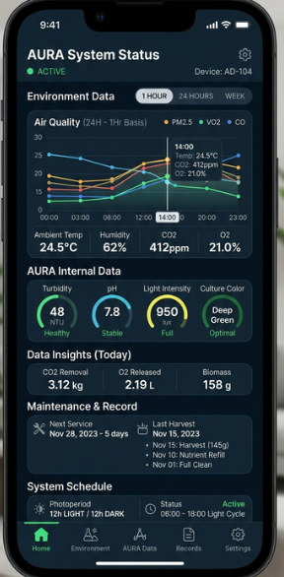 (sample)

OBJECTIVES
- Users can access to data of different sensors to know air quality and performance of air regenerator
- Users can control things like lighting and bubbling > Auto maintenance (future)
- Reminders on harvesting timeline and platform to purchase media/ upgrade/ troubleshoot

PLUS POINTS
- Creating new trend as in grow your algae (like its pet- Pou)
- Form the community (eco and space conscious)

HARDWARE and SENSORS IOT
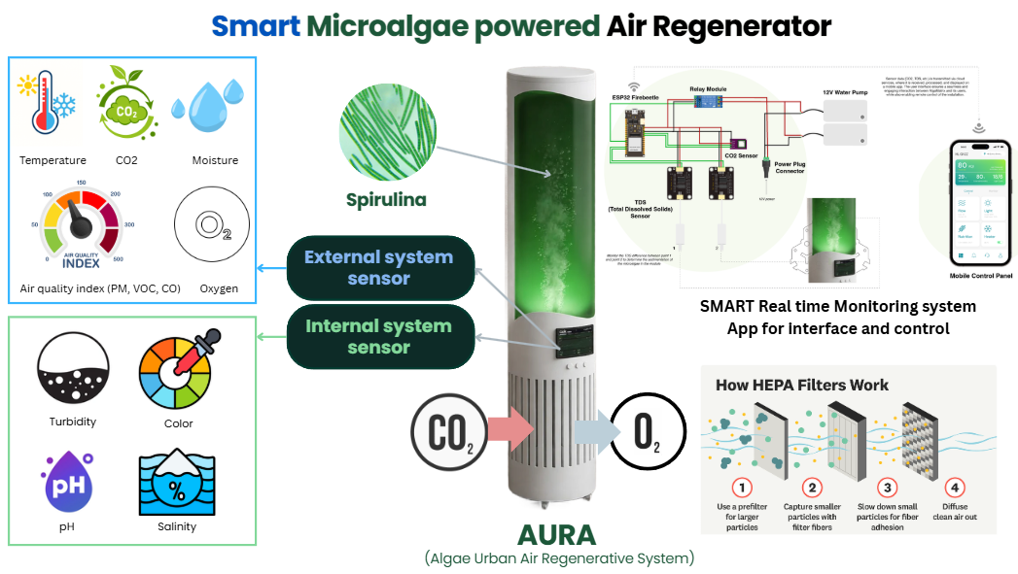
- ESP32 was used
- Sensors we have (most necessary)- RGB color sensor, Air quality sensor (CO2, Temperature, Humidity)

🎨 Design System & Aesthetic
- Theme: Light and Dark mode by default (fits the "tech/biotech" vibe, and makes glowing green/blue data visualization pop).
- Primary Accent: Bio-Green (representing algae health and carbon capture).
- Secondary Accent: Cyber-Blue (representing the AURA hardware and data stream).
- Typography: Clean, geometric sans-serif (e.g., Inter or SF Pro) for high readability in data tables and graphs.

📱 App Structure & Wireframe Flow

1. Dashboard (The Home Screen)
The central hub giving an immediate snapshot of the AURA system's health and high-level achievements.
- Header: Device status indicator (e.g., "🟢 AURA System-01: Active") and quick notifications for maintenance.
- The "Impact" Widget (Insights): A hero section at the top showing lifetime or daily environmental impact.
  - Metrics: CO2 Removed (g/kg/L), O2 Released (g/kg/L), Biomass Generated (g/kg).
  - Visual: A 3D-rendered or animated digital algae cell that glows brighter based on productivity.
- Photoperiod Ring: A circular progress tracker showing the 12h:12h light/dark cycle.
  - Visual: Half-sun, half-moon icon dial indicating current time remaining in the current cycle (e.g., "6h 12m remaining in Light Period").
  - Allow clients to control what time to what time for lighting and dark

2. Environment Data Screen (Air Quality)
Focuses on the external air being pumped into or monitored around the system.
- Time-Granularity Toggle: 1 Hour | 1 Day | 1 Week (Defaulting to the requested 1-hour basis over a day view).
- Interactive Multi-Graph:
  - A smooth line graph that lets users swipe left/right to see 1-hour intervals across 24 hours.
  - A "scrubber" vertical line that lets users tap and drag to see exact values at any specific minute.
- Metric Grid: Below the graph, cards display real-time numbers. Tapping a card changes the main graph focus to that specific metric:
  - 🌡️ Temperature & Humidity (Combined card)
  - 🌫️ PM (2.5 / 10) & VOCs (Air purity indicators)
  - 💨 CO2 vs. O2 Levels (Inflow ambient air composition)
  - ⚠️ CO (Carbon Monoxide) (Safety threshold indicator)

3. AURA Internal Data Screen (The Bioreactor)
Dedicated to the liquid environment inside the algae tank itself. This requires specific biological guardrails.
- Status Gauges: Instead of standard line graphs, use radial dials with "Safe Zones" highlighted in green, as these metrics must stay within strict biological limits.
- Metrics Layout:
  - Turbidity (Algae Density): Indicates when the algae is thick enough to harvest.
  - pH Level: Critical for algae survival; includes a visual marker if it gets too acidic or alkaline.
  - Light Intensity: Shows the lux/PAR output of the internal LEDs.
  - Color Sensor Data: A small digital color swatch showing the exact shade of green the internal camera detects (helps diagnose contamination or die-offs early).
  - Water levels sensor: Understand water loss across time

4. Maintenance & Records Screen
The practical utility side of the app for long-term hardware health.
- Upcoming Maintenance Card:
  - Countdown to the next water change, filter replacement, or algae harvest (e.g., "Next Harvest due in 3 days").
- Log Book (Timeline View): A clean, vertical scrolling timeline of past events.
  - June 02, 2026: Water flush & nutrient refill completed by User.
  - May 18, 2026: System calibrated (pH sensor reset).
- "Log Action" Button: A floating action button (+) that lets users manually record when they clean the tank, add nutrients, or harvest biomass.

💡 UX Micro-Interactions & Features
- Predictive Insights: Don't just show data; explain it. Add a small "AURA Insight" text box at the bottom of the dashboard.
  - Example: "Biomass growth has peaked. Consider scheduling a harvest to optimize CO2 absorption rates."
- Color-Coded Alert States: * Green: System nominal.
  - Amber: Attention needed (e.g., 12h:12h photoperiod skipped due to manual override, or pH drifting).
  - Red: Critical failure (e.g., air inflow blocked, pump failure).

🛠️ Recommended Component Architecture (For Developers)
UI Component | Type | Data Input
Main Impact View | Summary Cards | Calculated metrics from CO2 delta sensors
Air Quality Chart | Recharts / Chart.js (Line) | 1-hour aggregated sensor arrays (Temp, PM, etc.)
Internal Bioreactor Gauges | Radial Bar Charts | Real-time pH, Turbidity, and Lux streams
Photoperiod Switcher | Time-based Toggle | Automatic 12h ON / 12h OFF relay controller

Business
An indoor microalgae air regenerator (1–1.5L) = a living, bio-based air regenerator device

To validate

Criteria for target audience B2C [Beach head]
#1 Health-Conscious Urban Professionals (25–45)
- Live in apartments/condos with poor ventilation
- Already buying air purifiers, plants, supplements
- Science-curious, willing to pay for innovation
- Kuala Lumpur, PJ, Penang type profiles locally
#2 Parents with Young Children / Babies
- Extremely sensitive to indoor air quality
- Fear of pollutants, dust, VOCs affecting kids
- Emotionally high-stakes purchase = strong conversion
#3 Allergy & Asthma Sufferers
- Actively searching for air quality solutions
- Have existing spend on air purifiers, medication
- Pain point is very real and recurring
#4 Eco-Conscious / Sustainability Buyers
- Love that it's living and natural vs mechanical filters
- Will talk about it, share it = organic word of mouth
- Drawn to the bio-tech novelty angle

Setting of B2C Target audience
- Lives in a room (Rent) - spend long time in room
- Work from Home/ Freelance individual - spend long time in room
- Wellness and Ecoconscious individuals

Criteria for target audience B2B

Criteria for target audience B2B [Beachhead]
#1 Wellness Centres (Clinics, Spas, Yoga Studios, Hair/Beauty Salons)
- Air quality is part of the product experience, not just a background utility
- Clients already pay a premium for "clean," "detox," "natural" positioning
- Owners are receptive to novel wellness-tech that reinforces brand story
- Small-to-mid room sizes fit the 1–1.5L unit well (treatment rooms, reception)
#2 Corporate HQ / Offices (Lobbies, Open Workspaces, Meeting Rooms)
- Air quality tied directly to employee wellbeing, productivity, and retention narratives
- ESG / sustainability reporting is now a boardroom priority — a "living" device is a visible, talkable asset
- Facilities/procurement budgets exist for air purification already (HVAC, purifiers)
- Lobby placement = passive brand statement to visitors and clients
#3 Shopping Malls (Common Areas, Entrances, High-Traffic Zones)
- High footfall = high visibility for a novel, photogenic bio-device (marketing value for mall owners)
- Malls compete on "experience" and differentiation, not just retail mix
- Sustainability/green-mall certifications increasingly matter for tenant and shopper appeal
- Facilities teams manage air quality at scale — open to pilot programs
#4 Hospitality (Hotels — Lobbies, Rooms, Spa/Wellness Facilities)
- Guest experience and "wellness travel" trends make air quality a differentiator
- Hotels already invest in ambience (scent, lighting, plants) — natural fit for a living air device
- Sustainability-certified hotels (green building, eco-tourism) need authentic ESG talking points
- Potential for premium "wellness room" upsell tied to the device
#5 Property Developers (New Residential/Commercial Buildings)
- Amenity differentiation is a core sales lever in new developments
- Green building certifications (GBI, LEED, etc.) reward innovative sustainability features
- Show units / sales galleries need standout, story-worthy installations
- Potential for bulk/B2B2C model — device bundled into units or common areas at scale

Setting of B2B Target audience
- Wellness centre- Clinic, Spa, Yoga, Hair cut - People looking for good air + ambience + comfort
- Corporate HQ lobby / working area - People looking for good air + sustainability
- Shopping mall
- Hospitality — hotels
- Property developer- new building/ residential area

Sales engineering
Sales positioning to counter resistance and to create a new space where we are the dominant player/ monopoly
- Come in from the perspective of perceived values [Sell Outcome + Identity + Experience → Technology]

Do NOT sell: | Sell:
- algae,  - carbon capture,  - filtration technology,  - photobioreactors.  Those are technical mechanisms. | - Identity  - Emotion  - Visibility  - Strategic outcomes.
People do not buy:  - HEPA filters  - System  - sensors,  - Dashboard | People buy:  - healthier lifestyle/ wellness  - prestige/ regenerative luxury  - peace of mind/ calm  - modernity/ futuristic ambiance,  - innovation identity  - freshness
Instead of defining as  - air purifier company  - carbon capture company  - microalgae company | Define as  - Living air regenerative system  - Green system/ facility/ infrastructure  - Biophilic Smart Environmental Systems
Pitching angle
- Become the first living regenerative XXX.
- A visible climate and air innovation showcase for students/ employees and visitors.
- We transform your building into a living sustainability experience.

Strategy
- Active approach to get early adopters
  - Within the network
  - Within the reach (physical shop)
- Prioritize scaling and network
  - Make it common to public, build up awareness and acceptance
- Create an environment where people enquire instead of active reaching out (except huge contract)

Business validation
Purpose
- Understand
  - Problem
    - Do they have problems in Air Quality, ESG/ Sustainability initiatives, Green facilities/ decorations
    - Current initiatives- Air Purifier, Sustainability initiatives, Green Decoration
  - Demand + Perceived values
    - So if this looks interesting to the company
    - What are the perceived values: Environmental sensing, Air & Climate Regeneration, Sustainability showcase/ Visual/ Green marketing, ESG Data management or OTHERS
  - Budget
    - Ask first how much they would pay
    - Reveal how much we would charge: Installation and Subscription cost
  - Objection/ Hesitation
    - Hassle/ Operation
    - Too little impact
    - No space
    - Not interested/ needed no strong motivation/ drive for them to act (no lost if not doing it)
    - Certification/ Data
    - Electricity consumption
    - Safety
    - Too expensive/ Not worth it. What are they comparing with
  - Decision making process
    - What is the department making the process, Who needs to approve it
    - How to do a pilot [Organisation, Person in charge, Department, Position, Email, Phone, Interest level, Hesitation]

Preparation
- One page concept sheet
  - Problem
  - Solution + Visuals
  - Benefits [Environmental sensing, Air & Climate Regeneration, Sustainability showcase/ Visual/ Green marketing, ESG Data management]

Question
- How should I do the pilot?

Follow
- Direct competitors
  - ATOZ (Microalgae based air purifier in Malaysia, not selling)
  - Algen Air, Algreen (Microalgae based air purifier overseas)
  - Normal air Purifier- LG, Panasonic, Coway, Dyson
- Indirect competitors
  - Sustainability showcase
    - Reverse vending machine
    - Modern Recycling station/ booth
    - Green Marketing booth
  - Employee wellbeing
- Future competitors
  - Algae Living
  - Biolina

Financial

Cost of company

Pilot
The first pilot should prove 3 things:
- The technology works.
  - Install successfully?
  - Is maintenance successful?
  - Monitoring success?
  - Data and App function?
  - Leakage, Contamination, Odor
- The customer sees value.
  - Do people care?
  - Will customer continue using it
  - Visitors notice and see it
  - Feedbacks
- The operating model is practical.
  - Cost and logistic
  - Frequency for maintenance

Algae Decarbon Early Pilot Program (ADEP)
Pilot structure
- 3 months [October-December 2026]
- Customer pay RM500-1000 + Visible placing + Monthly feedbacks + Permission for marketing

